Response Time in the Los Angeles Police Department:

Changes and Trends, 2010-2014

White Paper #2

By

Marc L. Swatt

Alese Wooditch

Craig D. Uchida

December 2015

Introduction

This report is the second in a series of reports that examine calls for service and response times in the Los Angeles Police Department (LAPD). The first report examined response time over calendar year 2014. In the current study we consider how response time performance has changed over a five-year period, 2010-2014. We examine three important aspects of the LAPD’s total response time: 1) evaluate the performance of the 1 percent trimmed geometric mean response time, 2) identify trends in yearly and monthly response time, and 3) explore yearly changes in response time across the 21 LAPD geographic divisions.

Background

The LAPD receives about 1.8 million calls per year. These calls include emergency calls (911), non-emergency calls (7-digit calls), and officer-initiated calls. Many of the 911 calls are for information purposes and do not require an officer to be dispatched. Others are more serious and take priority over less serious calls. A Code 3 call has the highest priority (crime in progress or has occurred within 10 minutes), followed by a Code 2, which is used for crimes that occurred in the last 15-30 minutes.

Calls are processed through the Computer Aided Dispatch (CAD) system. An operator takes the call and enters information into the system for the dispatcher. The dispatcher prioritizes the call and notifies the patrol unit regularly assigned to the area. Officers respond through their mobile digital terminals or verbally to the dispatcher. Throughout the process of the call, the officers record the time. A timestamp is recorded when: the officer acknowledges the call, the officer is en croute, the officer arrives on scene, and the officer completes the call. A disposition code is also used to identify the outcome of the call. If a crime has occurred then a police report is filed, if not, the incident may be noted on the officer's daily activity form.

Data

For the current report, we used all calls-for-service recorded in CAD from 2010 to 2014. We excluded calls that were "missing by design." A review of the calls-for-service for 2014 found that the response time values for 938,525 of the 1,787,656 records (52.5 percent) were missing by design and these cases were accounted for by five rules:

- Priority > 3 : 4 records
- Call Type = 006 : 837,047 records
- Call Type = 902 : 87,350 records
- Call Type = 200, 2001, 720, 7201, 7202, 7203, 7204, 720O, 820, 8201,
8201W, 8202, 8202W, 8203, 8205, 8205W, 820H, 820O, 820OW : 12,328 records
- Call Type = 100 : 1,796 records

Total response time was calculated using a query currently in use by the LAPD and records that fit the missing by design rules were excluded from the CAD data extract. This resulted in a total of 4,071,924 calls over this five-year period. Of these data, 271,302 records (6.6 percent) were excluded due to 270,392 records not containing calculated values for total response time, 784 had illogical response time values (38 negative values and 746 zero values), 21 for having a priority level of 1, and 105 due to invalid call type. This left a total of 3,800,622 records to include in the response time analysis below.

Evaluate the Performance of the 1 Percent Trimmed Geometric Mean
A concern about outliers resulted in the LAPD adopting the median response time as the measure of call time performance. While the median is naturally robust against outliers, this measure is inefficient and may not sufficiently capture improvements/declines in call response time. Since one of the recurrent problems with the response time data is the presence of a substantial number of outliers, we proposed a process for trimming mean response times in the first report. We determined that a 1 percent trimmed geometric mean is appropriate for measuring performance across the entire LAPD over a one-year period. The process for calculating mean response time is as follows: 1) transform response time using the natural logarithm; 2) trim the top 1 percent and bottom 1 percent for each priority; 3) find the mean of the remaining data; and 4) back transforming (exponentiating) the result.

The 1 percent trimmed data was effective for measuring yearly performance across the LAPD but it was not evaluated for smaller time windows. To assess whether this metric was appropriate for a shorter time span, the performance of the 1 percent trimmed geometric mean response time was examined at the monthly level. This was accomplished by employing the process proposed in the Phase I Response Time Study Report and was computed separately for each month for 2010 to 2014 (response times with the top 1 percent and bottom 1 percent for each month were trimmed irrespective of priority level). As a comparison, the degree to which outliers influence the distribution of response time was also evaluated with data trimmed 5 percent, 10 percent, and 25 percent.

The monthly level data include an average of 63,344 calls per month (SD=5,153). Figure 1 illustrates that there is a seasonal pattern to the LAPD call volume, with a higher number of calls in the summer months in comparison to winter months. The maximum number of calls during the period was 72,328 in July of 2014 and the minimum was 50,727 in February of 2011.

Figure 1: Total Number of Calls-for-Service by Month, 2010-2014
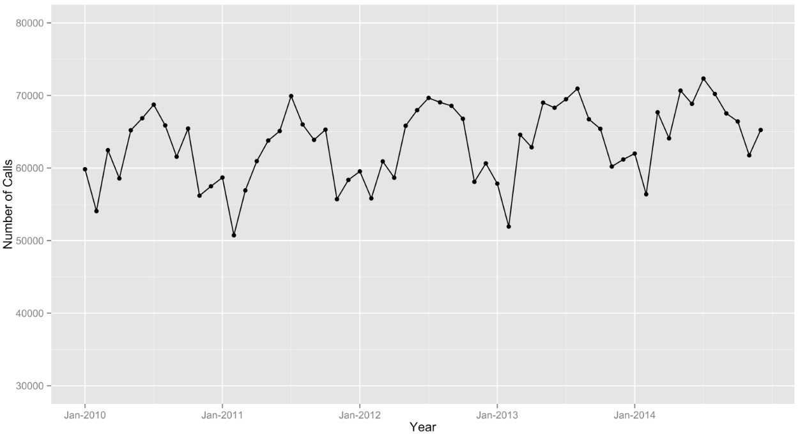

The average number of monthly calls by priority level is 30,433 calls for priority 0 (SD=2,960),
23,027 calls for priority 2 (SD=2,001), and 9,884 calls for priority 3 (SD=623). Priority 2 calls have seen the greatest percent increase between 2010 and 2014 (+13.1 percent), with priority 0 and priority 3 calls experiencing a smaller increase or slight decline.

The greatest dissimilarity between the different percent trims of the data occurs between November 2013 and June 2014, and outside of this period, there is little variance in the geometric means between the various percent trims. The divergence in the geometric mean total response time across months is depicted in Figure 2. While there is more variability in the trimmed means between November 2013 and June 2014, the difference between the 1 percent and 5 percent trim is minor. The largest disparity occurs in December of 2013, with a difference of 10.2 seconds.

Figure 2: Line Graph of Geometric Mean Response Time Trimmed 1% and 5% by Month, 2010-2014
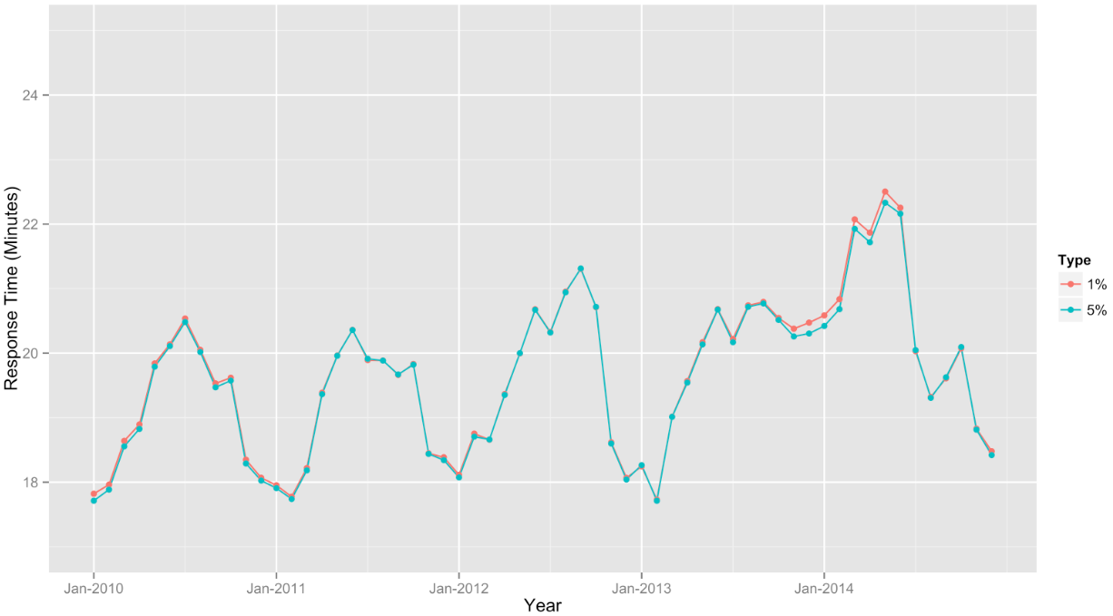

A series of box-and-whiskers plots (Figure 3) were conducted with the 1 percent trimmed data for each month to identify outliers, which is considered a response time that falls outside 1.5 times the interquartile range above the upper quartile and below the lower quartile of the distribution of monthly data (25 percent and 75 percent order statistics). No outliers in the monthly logged response times were identified, including months with greater variability in the trimmed response times. This suggested that the 1 percent trim still provides sufficient protection against outliers at the monthly level and will be used for examining changes in mean response time over time below.

Figure 3: Box-and-Whiskers Plots of Logged Mean Response Time Trimmed 1% by Month, 2013-2014
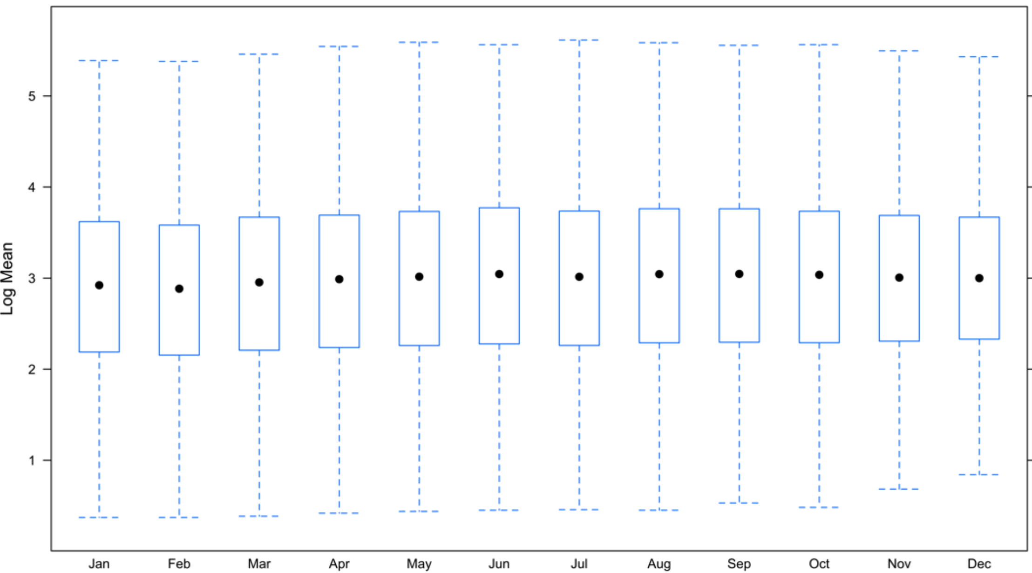
percent

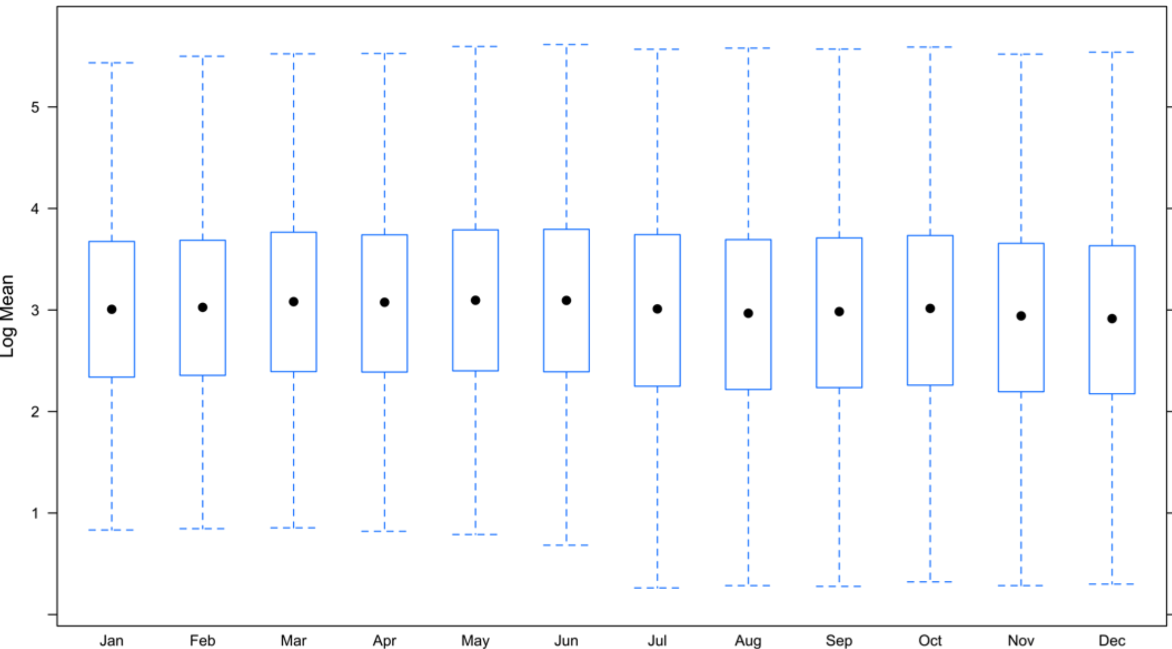
percent

Trends in Response Time over Time

Table 1 presents the geometric mean response time that was computed for each year after trimming the top and bottom 1 percent of cases. The average for the 2010 to 2014 time period is 19.69 minutes. Slight increases in the total response time each year for the time period are observed. These yearly trends are depicted in Figure 4.

Total response time increased from a low of 19.16 minutes in 2010 to a high of 20.52 minutes in 2014, which is an increase of 1.36 minutes or a 7.10 percent increase over a five-year period. The largest increase in total response time was between 2013 and 2014, which was an increase of 0.60 minutes or a 3.01 percent increase from the prior year.

The smallest increase in total response time was between 2010 and 2011, which was an increase of 0.03 minutes or a 0.16 percent increase from the prior year. These changes in total response time follow an overall increase in the number of calls-for-service during the period: 742,256 calls in 2010, 735,308 calls in 2011, 761,504 calls in 2012, 768,437 calls in 2013, and 793,117 calls in 2014. The use of the median to assess response time would lead to overestimating total response time for three of the five years. The difference in minutes between median response time with untrimmed data versus the geometric mean response with data trimmed 1 percent for the same period is as follows: 0 in 2010, +0.24 in 2011, +0.26 in 2012, +0.16 in 2013, and -0.04 in 2014.

Table 1: Geometric Mean Total Response Time by Year, 2010-2014
Year | Mean Response  Time in Minutes | Median Response  Time in Minutes | Yearly ∆  in Minutes | Total ∆ from  Year Prior (%)
2010 | 19.16 | 19.16 | -- | --
2011 | 19.19 | 19.43 | 0.03 | + 0.16
2012 | 19.67 | 19.93 | 0.48 | + 2.50
2013 | 19.92 | 20.08 | 0.25 | + 1.27
2014 | 20.52 | 20.48 | 0.60 | + 3.01
∆ Denotes change in geometric mean total response time from the prior yea

The geometric mean total response time was computed for each priority level by year after trimming the top and bottom 1 percent of cases (see Figure 4). Priority level 3 calls have the lowest average response time with 6.61 minutes for years 2010 to 2014, followed by priority level 2 at 16.11 minutes and priority level 3 at 32.89 minutes. The most substantial increase in total response time during the time period is for priority 0 calls between 2012 and 2014, which had a 1.33-minute increase. While priority 2 and 3 calls had a comparably smaller increase in the total number of minutes during the same time period, the percent increase in priority 2 (5.90 percent) and 3 (8.09 percent) response times was larger in comparison to priority 0 (4.05 percent) calls.

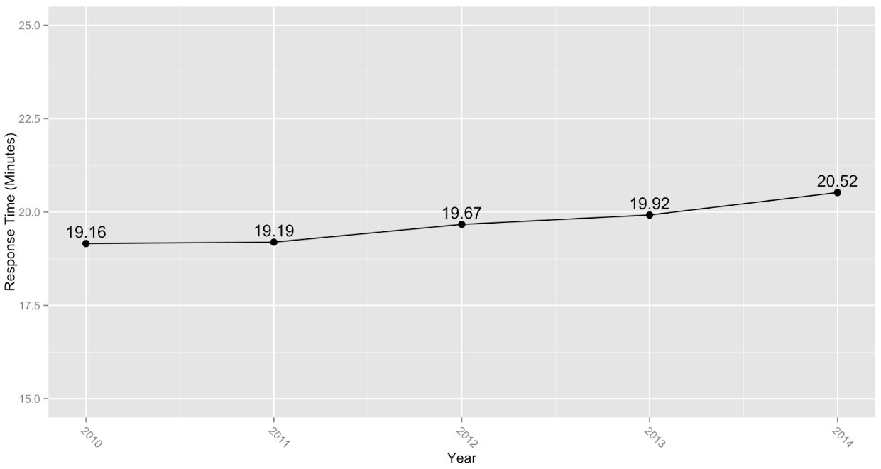
Figure 4: Line Graph of Geometric Mean Total Response Time by Year, 2010–2014

Trends in monthly call volume by priority level suggests that overall increases in mean yearly response time may be due to longer response times for priority 0 calls (Figure 5), especially given that the majority of calls are priority 0. There is also a notable increase in monthly response time for priority 2 and 3 calls between November 2013 and June 2014.

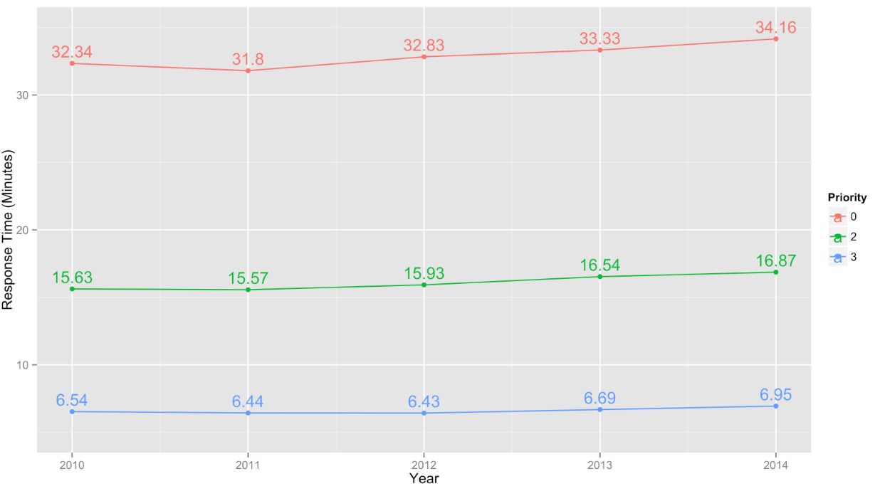
Figure 5: Geometric Mean Total Response Time by Priority Level and Year, 2010-2014

Year | Priority Level
 | 0 |  |  | 2 |  |  | 3
 | Mean  Time | Response  Time ∆ (Min) | Response  Time ∆ (%) | Mean  Time | Response  Time ∆ (Min) | Response  Time ∆ (%) | Mean  Time | Response  Time ∆ (Min) | Response  Time ∆ (%)
2010 | 32.34 | -- | -- | 15.63 | -- | -- | 6.54 | -- | --
2011 | 31.80 | -0.54 | -1.67% | 15.57 | -0.06 | -0.38% | 6.44 | -0.10 | -1.53%
2012 | 32.83 | +1.03 | +3.24% | 15.93 | +0.36 | +2.31% | 6.43 | -0.01 | -0.16%
2013 | 33.33 | +0.50 | +1.52 % | 16.54 | +0.61 | +3.83% | 6.69 | +0.26 | +4.04%
2014 | 34.16 | +0.83 | +2.49% | 16.87 | +0.33 | +2.00% | 6.95 | +0.26 | +3.89%
All Years | 32.89 | -- | -- | 16.11 | -- | -- | 6.61 | -- | --

∆ Denotes change in geometric mean total response time from the prior yea

The total response time by month is presented in Figure 6, whereby the geometric mean response time was computed monthly after trimming the top and bottom 1 percent of cases. Slight increases in total response time are again observed, with the most substantial increases from the year prior being between November 2013 and June 2014. There is a clear seasonal pattern to total response time, as there are longer response times during summer months. The lowest response time occurred in February 2013 with a mean of 17.72 minutes, while the highest response time occurred in May 2014 with 22.50 minutes. The geometric mean total response time across months between 2010 and 2014 is 19.68 minutes. The seasonal pattern in monthly response time tends to follow trends in total number of calls across time as seen in Figure 6.

Figure 6: Geometric Mean Response Time by Priority Level and Month of Year
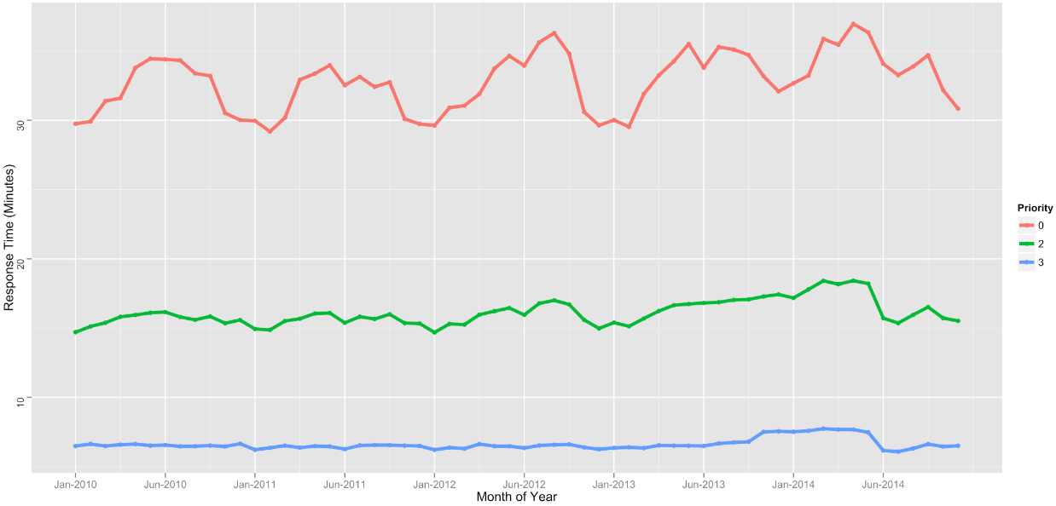

Differences in Response Time across the LAPD Geographic Divisions
The mean response time for each of the 21 geographic divisions of the LAPD was examined for 2010 to 2014. The geometric mean total response time was computed for each year by division using data trimmed 1 percent and then averaged across years. The total mean response times are presented in Table 2 and are ranked ascending by response time (divisions with shortest time appear towards the top of the table). The total response time weighted by division is 19.39 min in 2010, 19.44 min in 2011, 19.91 min in 2012, 20.16 min in 2013, and 20.75 min in 2014, and an overall average of 19.93 minutes across years. The divisions with the shortest average response time in minutes during the observation period are Central (13.42 min), Southeast (17.43 min), Hollywood (19.05 min), 77th Street (19.05 min), and Rampart (19.37 min). The divisions with the longest average response times during the observation period are Foothill (22.41 min), West Los Angeles (22.31 min), Northeast (21.85 min), Newton (21.33 min), and Hollenbeck (20.93 min).

Figure 7: Geometric Mean Total Response Time by Month, 2010–2014
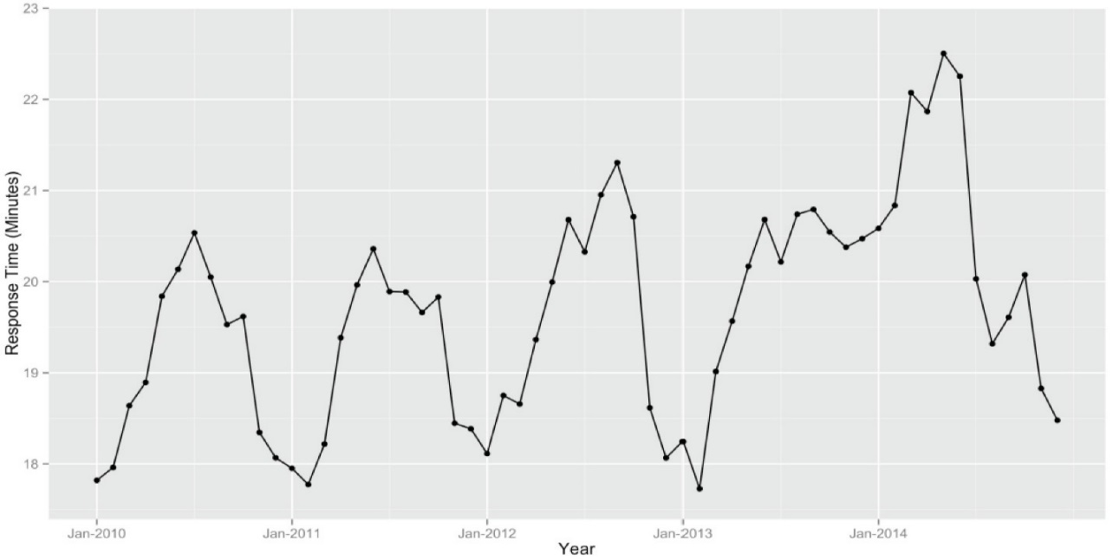

Table 2: Mean Total Response Time by LAPD Division, 2010-2014 in Rank Order
Rank | Division | Mean Response Time by Year (in Minutes) |  |  |  |  | Average  2010 - 2014
 |  | Y2010 | Y2011 | Y2012 | Y2013 | Y2014
1 | Central | 13.43 | 13.55 | 13.50 | 13.64 | 12.98 | 13.42
2 | Southeast | 16.33 | 16.13 | 17.95 | 17.82 | 18.90 | 17.43
3 | Hollywood | 18.01 | 19.84 | 19.57 | 19.50 | 18.34 | 19.05
4 | 77th Street | 17.82 | 18.39 | 18.74 | 19.97 | 21.95 | 19.37
5 | Rampart | 18.56 | 18.05 | 19.80 | 20.02 | 20.60 | 19.41
6 | West Valley | 19.46 | 19.91 | 19.60 | 18.91 | 19.33 | 19.44
7 | Van Nuys | 18.71 | 19.58 | 19.38 | 19.73 | 20.12 | 19.50
8 | Olympic | 18.55 | 19.90 | 19.23 | 19.63 | 20.37 | 19.54
9 | Wilshire | 18.27 | 20.21 | 19.33 | 19.09 | 20.81 | 19.54
10 | Harbor | 20.44 | 19.82 | 18.69 | 20.88 | 20.54 | 20.07
11 | North Hollywood | 20.75 | 19.83 | 19.62 | 20.28 | 20.81 | 20.26
12 | Southwest | 19.12 | 18.47 | 21.25 | 20.00 | 22.76 | 20.32
13 | Mission | 19.96 | 20.01 | 20.61 | 21.18 | 21.14 | 20.58
14 | Pacific | 20.68 | 19.27 | 19.78 | 20.89 | 22.33 | 20.59
15 | Devonshire | 20.94 | 20.17 | 20.69 | 20.87 | 20.33 | 20.60
16 | Topanga | 20.43 | 19.03 | 20.08 | 21.48 | 22.07 | 20.62
17 | Hollenbeck | 20.39 | 19.78 | 21.23 | 21.36 | 21.87 | 20.93
18 | Newton | 19.54 | 20.27 | 21.98 | 22.11 | 22.76 | 21.33
19 | Northeast | 21.58 | 21.25 | 21.51 | 22.17 | 22.74 | 21.85
20 | West Los Angeles | 21.44 | 22.15 | 22.96 | 21.63 | 23.38 | 22.31
21 | Foothill | 22.86 | 22.73 | 22.57 | 22.14 | 21.77 | 22.41
 | Yearly Average* | 19.39 | 19.44 | 19.91 | 20.16 | 20.75 | 19.93

*This yearly average is weighted by the 21 police divisions and does not include cases with division codes greater than 21.

A choropleth map of the 21 LAPD divisions’ mean total response time (presented in Table 2) appears in Figure 8. This 5-color thematic map shades each division by their total response time for 2010 to 2014, whereby geometric means were computed with data trimmed 1 percent for each year and then averaged across years. For 2010 to 2014, the mean total response time weighted by division is 19.93 minutes. It is evident from Figure 8 that divisions with a larger geographic area tend to have longer response times.

The overall percent change in the mean total response time is presented for each division in Table 3 for years 2010 to 2014. Four of the 21 divisions had an average percent decline in response time for 2010 to 2014: Foothill (-1.21 percent), Central (-0.82 percent), Devonshire (-0.70 percent), and West Valley (-0.14 percent). The Foothill division had the longest average response time out of all 21 divisions (22.41 min) for 2010 to 2014; however, it had the greatest percent decline in response time over the period and is the only division that has seen continual declines in mean response time every year.

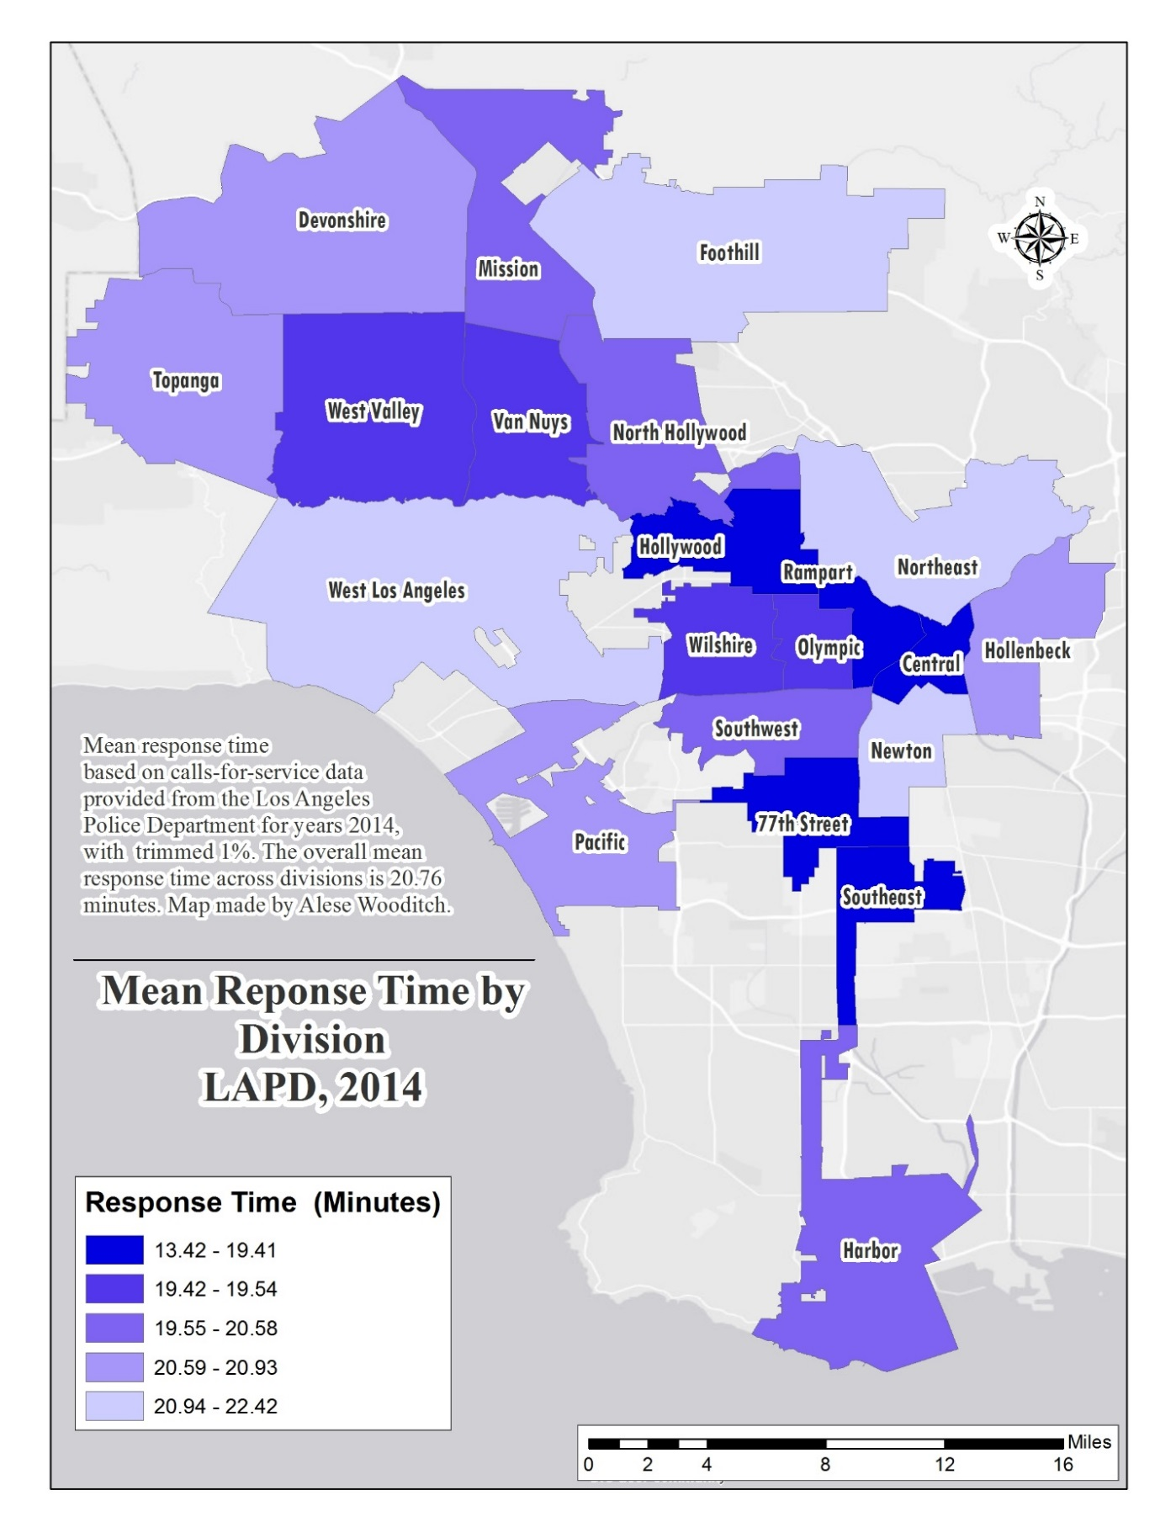
Figure 8: Choropleth Map of Geometric Mean Total Response Time, 2010-2014

Table 3: Percent Change in Response Time by LAPD Division, 2010-2014, in Rank Order
Rank | Division | Percent Change in Total Response Time |  |  |  |  | Yearly Average
 |  | 2010  to 2011 | 2011  to 2012 | 2012  to 2013 | 2013  to 2014 | 2010  to 2014
1 | Foothill | -.57 | -.70 | -1.91 | -1.67 | -4.77 | -1.21
2 | Central | .89 | -.37 | 1.04 | -4.84 | -3.35 | -.82
3 | Devonshire | -3.68 | 2.58 | .87 | -2.59 | -2.91 | -.70
4 | West Valley | 2.31 | -1.56 | -3.52 | 2.22 | -.67 | -.14
5 | North Hollywood | -4.43 | -1.06 | 3.36 | 2.61 | .29 | .12
6 | Harbor | -3.03 | -5.70 | 11.72 | -1.63 | .49 | .34
7 | Hollywood | 10.16 | -1.36 | -.36 | -5.95 | 1.83 | .62
8 | Northeast | -1.53 | 1.22 | 3.07 | 2.57 | 5.38 | 1.33
9 | Mission | .25 | 3.00 | 2.77 | -.19 | 5.91 | 1.46
10 | Hollenbeck | -2.99 | 7.33 | .61 | 2.39 | 7.26 | 1.83
11 | Van Nuys | 4.65 | -1.02 | 1.81 | 1.98 | 7.54 | 1.85
12 | Pacific | -6.82 | 2.65 | 5.61 | 6.89 | 7.98 | 2.08
13 | Topanga | -6.85 | 5.52 | 6.97 | 2.75 | 8.03 | 2.10
14 | West Los Angeles | 3.31 | 3.66 | -5.79 | 8.09 | 9.05 | 2.32
15 | Olympic | 7.28 | -3.37 | 2.08 | 3.77 | 9.81 | 2.44
16 | Rampart | -2.75 | 9.70 | 1.11 | 2.90 | 10.99 | 2.74
17 | Wilshire | 10.62 | -4.35 | -1.24 | 9.01 | 13.90 | 3.51
18 | Southeast | -1.22 | 11.28 | -.72 | 6.06 | 15.74 | 3.85
19 | Newton | 3.74 | 8.44 | .59 | 2.94 | 16.48 | 3.93
20 | Southwest | -3.40 | 15.05 | -5.88 | 13.80 | 19.04 | 4.89
21 | 77th Street | 3.20 | 1.90 | 6.56 | 9.91 | 23.18 | 5.40

Also in Table 3, the other 17 divisions experienced an overall increase in total mean response time, which was a 2.40 percent increase on average. The divisions with the greatest percent increase in overall response time were 77th Street (5.40 percent), Southwest (4.89 percent), Newton (3.93 percent), Southeast (3.85 percent), and Wilshire (3.51 percent). Despite Southeast and 77th Street being among the divisions with the shortest mean response times (17.43 and 19.05 min respectively), the two divisions are among the top 5 divisions with the greater percent increase in mean response time during the period. Southeast division experienced a 15.75 percent increase in total response time between 2010 and 2014. The 77th Street division experienced a 23.18 percent increase in total response time between 2010 and 2014.
The overall mean total response time for priority 3 calls in 2014 is presented in Figure 9 by division. The average mean response time for priority 3 calls in 2014 was 6.26 minutes when weighted by division. This reflects a slightly higher response time for priority 3 calls over the prior few years, which was 5.95 min in 2010, 5.80 min in 2011, 5.80 min in 2012, and 6.03 min in 2013. West Los Angeles (7.63 min), Northeast (7.19 min), Devonshire (7.08 min), Foothill (6.81 min), and Southwest (6.70 min) had the highest priority 3 response times among the divisions in 2014. Six of the 21 divisions had a priority 3 response time below 6 minutes in
2014: Central (4.57 min), Olympic (5.14 min), Hollywood (5.18 min), Rampart (5.51 min), Van Nuys (5.60 min), and Wilshire (5.76 min).

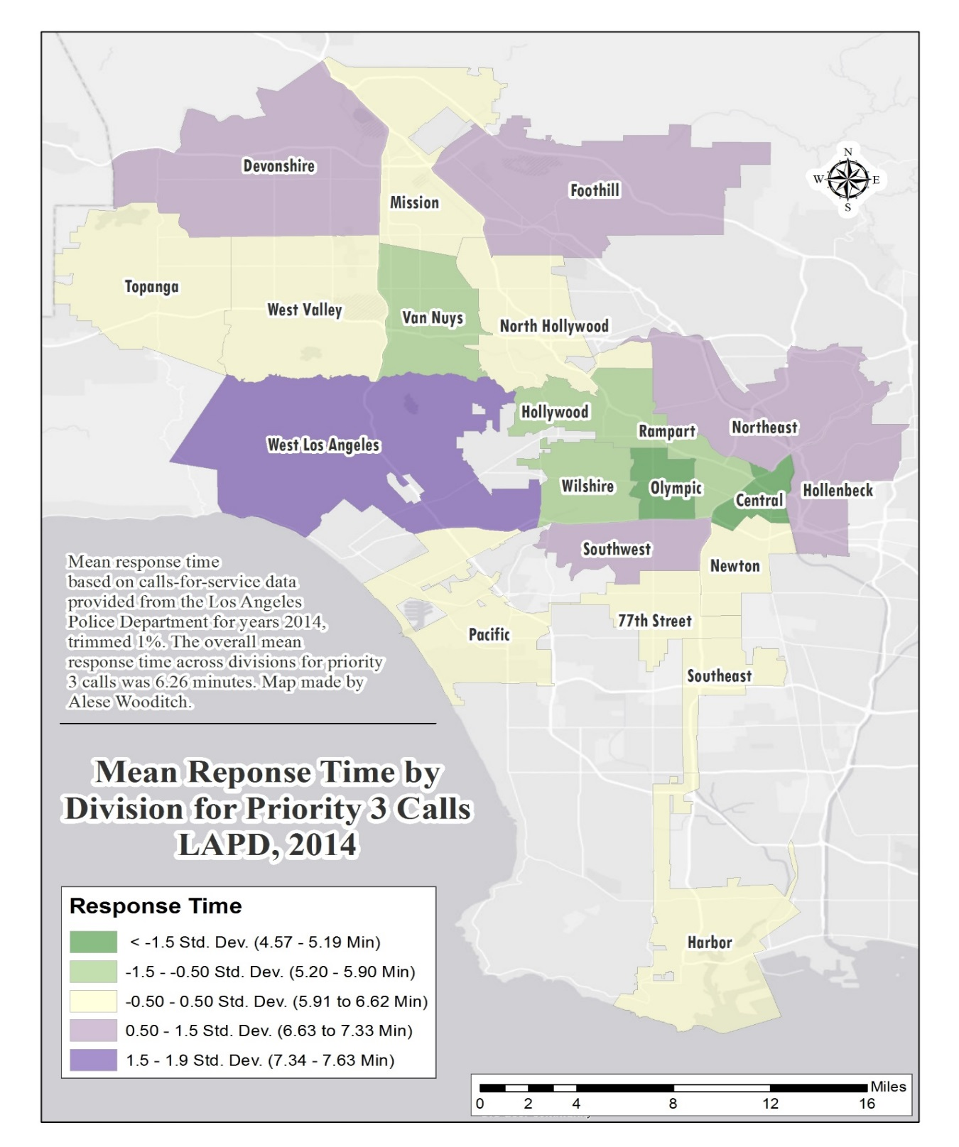
Figure 9: Choropleth Map of Geometric Mean Response Time for Priority 3 Calls (2014)

The overall percent change in the mean response time for priority 3 calls is presented for each division in Table 4 for years 2010 to 2014. Ten of the 21 divisions had a yearly average percent decline in overall response time for years 2010 to 2014. Among the divisions with the greatest declines are Devonshire (-1.78 percent), Harbor (-1.56 percent), Foothill (-1.55 percent), Topanga (-1.22 percent), and Central (-1.14 percent). The Devonshire and Foothill divisions had the longest average response time out of all 21 divisions (7.08 and 6.81 min respectively) in 2014; however, they both had the greatest percent declines among divisions in priority 3 response time over the period.

The other 11 divisions experienced an overall increase in mean response time for priority 3 calls, which was a 1.63 percent incline on average. The divisions with the greatest percent increase in overall response time were Southwest (4.49 percent), Newton (3.48 percent), 77th Street (3.15 percent), West Los Angeles (2.54 percent), and Southeast (1.80 percent). The greatest change in response time for priority 3 calls from 2010 to 2014 was an 18.04 percent increase for 77th Street and a 16.93 percent increase for Southwest.

Table 4: Percent Change in Priority 3 Response Time by LAPD Division, 2010-2014, in Rank Order
Rank | Division | Percent Change in Total Response Time |  |  |  |  | Yearly Average
 |  | 2010  to 2011 | 2011  to 2012 | 2012  to 2013 | 2013  to 2014 | 2010  to 2014
1 | Devonshire | -3.96 | .43 | 2.12 | -1.80 | -3.28 | -1.78
2 | Harbor | .16 | -7.37 | 6.60 | 2.54 | 1.41 | -1.56
3 | Foothill | -4.18 | -2.11 | 3.08 | 1.64 | -1.73 | -1.55
4 | Topanga | -5.85 | -.67 | 6.25 | 2.86 | 2.21 | -1.22
5 | Central | -6.11 | -.23 | 3.50 | 2.93 | -.22 | -1.14
6 | Mission | -3.78 | -1.19 | 5.01 | 1.97 | 1.81 | -1.00
7 | Pacific | -6.65 | -1.39 | 8.80 | 5.34 | 5.51 | -.90
8 | Olympic | 1.59 | -4.10 | 4.68 | .97 | 2.98 | -.51
9 | Van Nuys | -3.54 | -1.47 | 2.61 | 3.81 | 1.24 | -.40
10 | West Valley | -5.08 | 1.51 | 1.81 | 3.40 | 1.43 | -.06
11 | North Hollywood | -7.13 | .17 | .87 | 7.94 | 1.30 | .33
12 | Northeast | -3.03 | 1.93 | 2.77 | 2.13 | 3.75 | .34
13 | Hollenbeck | -5.11 | 3.70 | 5.03 | 3.40 | 6.87 | .66
14 | Wilshire | 3.75 | -3.25 | 4.67 | 2.86 | 8.07 | 1.12
15 | Hollywood | 2.86 | -1.59 | 4.65 | 2.12 | 8.18 | 1.13
16 | Rampart | -.61 | 2.24 | 3.19 | 3.67 | 8.70 | 1.77
17 | Southeast | -2.23 | 3.61 | 9.16 | 4.03 | 15.03 | 1.80
18 | West Los Angeles | -.68 | 2.32 | -4.13 | 5.97 | 3.25 | 2.54
19 | 77th Street | -.18 | -.18 | 7.89 | 9.80 | 18.04 | 3.15
20 | Newton | .00 | 4.74 | 2.68 | 5.71 | 13.68 | 3.48
21 | Southwest | -3.49 | 3.98 | 3.13 | 12.98 | 16.93 | 4.49

Conclusions
For this phase of the response time study, we examined the temporal patterns in response time from 2010 to 2014 and spatial patterns in response time across the 21 geographic divisions of the LAPD. From this phase of the response time study, have identified a number of conclusions and recommendations.

1. The 1 percent Trimmed Geometric Mean Performs Adequately for Shorter Time Periods and Smaller Geographic Areas.

One of the most important findings that this exercise has demonstrated is that the metric identified in the previous report, the 1 percent trimmed geometric mean, can be used as a general metric for assessing response time performance. First, we noticed some differences between the 1 percent trimmed geometric mean and the median over time, but these differences were not very substantial. This suggests that the 1 percent trimmed geometric mean and the median will be similar in magnitude. Since this is the case, the gain in efficiency of the 1 percent trimmed geometric mean supports its use over the median. Second, we observed that the 1 percent trimmed mean does not differ substantially from other reasonable choices for trimming (such as the 5 percent trimmed mean) across months. This is important because it suggests that maintaining the same proportion of trimmed data does not lead to insufficient protection against outliers nor does it result in too large a proportion of data trimmed from the sample. Further, the 1 percent trimmed geometric mean was usable for monthly data from separate divisions across the LAPD. Taken together, these results suggest that the 1 percent trimmed geometric mean can be used as a general metric for evaluating response time performance.

2. There Have Been Important Differences in Response Time from 2010 to 2014.

The temporal analysis has revealed that the average response time has increased over time period examined from a 1 percent geometric mean of 19.16 minutes in 2010 to a 1 percent geometric mean of 20.52 in 2014. While this increase in response time was observed for each priority, the largest percentage increase occurred for Priority 2 calls with an increase of 7.93 percent over the time period. While this difference is not substantial, it does suggest that response time is increasing and may be worth watching in the future. Further, there are clear monthly cyclical patterns over time where the summer months have increased numbers of calls for service as well as increased response times. The existence of these cyclical patterns suggests that it may be possible to generate predictive models to assist staffing decisions, but further research is needed to determine how the reliability of these cycles and the gains in efficiency from a predictive model.

3. There are Important Differences in Response Time across Divisions.

There are clear differences in response time dependent upon the responding division. Central and Southeast have the shortest average response times, while West Los Angeles and Foothill have the longest average response times. Further, there are differences across divisions on whether response time is increasing or decreasing and by how much. While these observations suggest that it would be valuable to generate response time performance metrics for each division over time, at the moment we must caution against using these to compare across divisions. There was a clear pattern in the average response time suggesting that the geographic area of the division was associated with the average response time. This would unfairly impact the performance of larger divisions, such as Foothill, West Los Angeles, and Devonshire without adequate control for the distance between the call and responding unit. Further, divisions may be impacted to the extent that their resources are disproportionately used by nearby divisions (such as with cross-ins or when there is “bleed over” of crimes from a hotspot on the border). Further investigation is necessary to determine whether an additional metric that addresses these issues can be developed for cross-division comparison purposes.

The Phase I Response Time Study Report provides additional detail on data 'missing-by-design'
Calls with the following types were excluded: ^006, ZUTEST, ZVTEST, ZXTEST, ZYTEST and ZZTEST.

